Unit 3 Section 1 : Pythagoras' Theorem
Pythagoras' Theorem relates the lengths of the sides in a right-angled triangle.
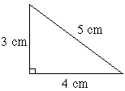 | A right-angled triangle has one angle of 90°.  The side opposite the right angle is always the longest side, and is called the hypotenuse.  The diagram on the left shows a right-angled triangle.  The lengths of the sides are 3cm, 4cm and 5cm.
The hypotenuse is the 5cm side because it is opposite the right-angle and it is the longest side.
Now look at the diagram on the right.  A square has been drawn on each of the sides of the triangle above.  We are going to examine the areas of each of the squares.  Shorter sides  The square on the 3cm side has an area of 3cm × 3cm = 9cm².  The square on the 4cm side has an area of 4cm × 4cm = 16cm².  Hypotenuse  The square on the 5cm side has an area of 5cm × 5cm = 25cm².  How they are related  If you add together the areas of the squares on the two shorter sides, you get 25cm². This is the same as the area of the square on the hypotenuse. | 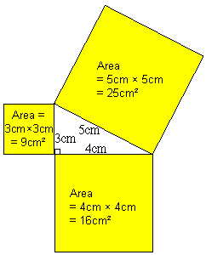
  (3cm × 3cm) | + | (4cm × 4cm) | = | (5cm × 5cm)
  9cm² | + | 16cm² | = | 25cm²

Pythagoras' Theorem
Pythagoras' theorem states that if you square the two shorter sides in a right-angled triangle and add them together, you
get the same as when you square the longest side (the hypotenuse).
In the triangle on the right, a and b are the two shorter sides and c is the  hypotenuse, so if we square a and b and add them together (a² + b²) we  get the same as if we square c (c²). Therefore, a² + b² = c². | 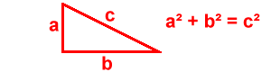

Example Question
We can use Pythagoras' Theorem to check if a triangle is right-angled, using the following method:
- Square the two shorter sides and add the values together.
- Square the longest side.
- Check if the results for (1) and (2) are the same.
If they are the same then the triangle is right-angled, otherwise it is not right-angled.
Practice Questions
Check if the following triangles are right-angled. They are not drawn to scale, so you can't tell by just looking at them.
Work out the answer to each of the questions below then click the button to see whether you are correct.
(a) | 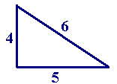 | (i) What do you get if you square the two shorter sides and add them together?  (ii) What do you get if you square the longest side?  (iii) Is the triangle right-angled?
(b) | 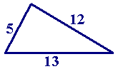 | (i) What do you get if you square the two shorter sides and add them together?  (ii) What do you get if you square the longest side?  (iii) Is the triangle right-angled?

Exercises
Work out the answers to the questions below and fill in the boxes. Click on the button to find out whether you have answered correctly. If you are right then will appear and you should move on to the next question. If appears then your answer is wrong. Click on to clear your original answer and have another go. If you can't work out the right answer then click on to see the answer.

Question 1
Which side is the hypotenuse in each of the following right-angled triangles?
(a) | 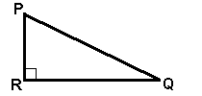
(b) | 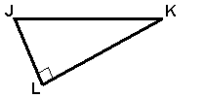
(c) | 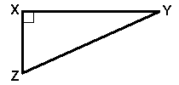
(d) | 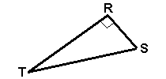

Question 2
Verify that each of the triangles below is right-angled, by following the steps:
(a) 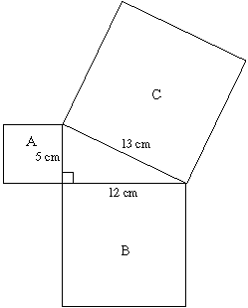 | (i) calculate the area of square A  cm²
(ii) calculate the area of square B
cm²
(iii) add together the area of squares A and B
cm²
(iv) calculate the area of square C
cm²
 | (v) Is the triangle right-angled?

(b) 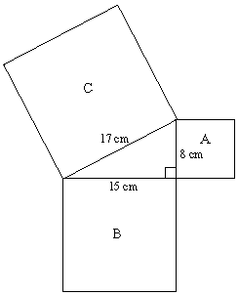 | (i) calculate the area of square A  cm²
(ii) calculate the area of square B
cm²
(iii) add together the area of squares A and B
cm²
(iv) calculate the area of square C
cm²
 | (v) Is the triangle right-angled?

(k) 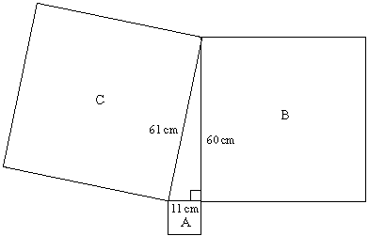 | (i) calculate the area of square A  cm²
(ii) calculate the area of square B
cm²
(iii) add together the area of squares A and B
cm²
(iv) calculate the area of square C
cm²
 | (v) Is the triangle right-angled?

Question 3
Check each of the three triangles below to see if they are right-angled.
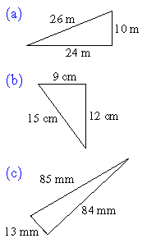 | Is triangle (a) right-angled?
 | Is triangle (b) right-angled?
 | Is triangle (c) right-angled?

Question 4
The whole numbers 3, 4, 5 are called a Pythagorean triple because 3² + 4² = 5².
A triangle with sides of length 3cm, 4cm and 5cm is right-angled.
Use Pythagoras' Theorem to check if these sets of numbers are Pythagorean triples:
(a) 15, 20, 25
(b) 10, 24, 26
(c) 11, 22, 30
(d) 6, 8, 9

You have now completed Unit 3 Section 1

Your overall score for this section is
Correct Answers
You answered questions correctly out of the questions in this section.
Incorrect Answers
There were questions where you used the Tell Me button.
There were questions with wrong answers.
There were questions you didn't attempt.

